Tokens vs Sessions

Badge

As Http is state-less we should have something like a badge to verify our identity.

There are two approaches for the badge information:

1. Badge containing our ID
2. Badge containing all of our information (but encrypted)

The first one is the session-based approach/ we should have information about a id and check them.

The second one is the token-based approach/ we should be able to read/decrypt all of the information.

Pros/cons:

Session:

+ easy to delete/modify sessions and accessibilities

* Need to match a user-ID and its information

Token:

+ easy to scale due to independency of the states(they are just need to be decrypted)

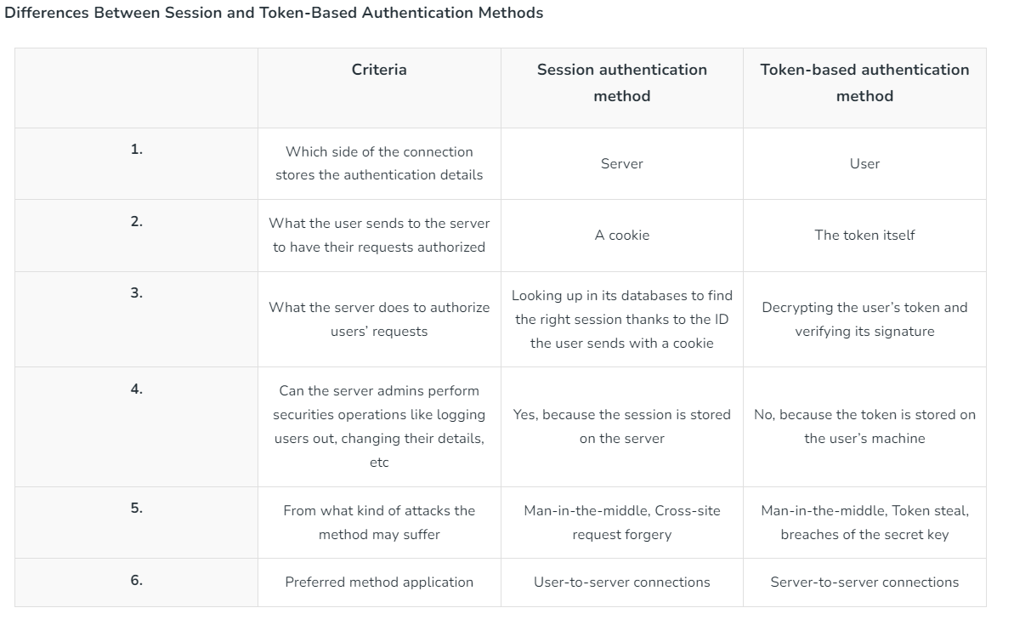

Resources:

* <https://www.geeksforgeeks.org/session-vs-token-based-authentication/>
* <https://sherryhsu.medium.com/session-vs-token-based-authentication-11a6c5ac45e4>
* <https://www.authgear.com/post/session-vs-token-authentication>